Novelty in the News: Detecting innovation with machine learning
DSPG Team: Quinton Neville (Columbia University), Raghav Sawhney (Virginia Tech)
SDAD Team: Devika Nair, Gizem Korkmaz, Neil Alexander Kattampallil
Sponsor: Gary Anderson, The National Center for Science & Engineering Statistics (NCSES) at the National Science Foundation (NSF)

Introduction
Innovation, from peanut butter to electricity, drives a country’s economic growth and is one of the foremost indicators of economic well-being around the globe. The National Center for Science and Engineering statistics (NCSES), a branch of the National Science Foundation (NSF), annually surveys the incidence of US-based innovation through the Business R&D and Innovation Survey (BRDIS). To measure innovation, the NCSES utilizes the Organisation for Economic Co-operation and Development’s Oslo Manual’s definition of innovation: the product must be new or significantly improved and the product be currently available on the market. While BRDIS broadly estimates how many companies produced an innovation each year, specific nuances are not well understood and deeper insight into quantitative and qualitative characteristics is needed. How many products are associated with a company’s innovation and what are these products? Are the products really novel or did a company simply replicate an existing product?
This research aims to develop methods to supplement the BRDIS survey and measure the quantity, degree, and temporal trends of product innovations. We developed machine learning methods to detect product innovations using publicly available news articles.
Data
The breadth of innovation, even when it is strictly defined by the Oslo manual, is vast, so the scope of the project was narrowed to the pharmaceutical and medical device industries. These industries appealed to our project goals for several reasons:
  - New drugs are strictly regulated by the FDA regulation.
  - New drugs are continuously launching to market.
  - FDA-approved drugs are our universe of eligible product-innovations.
Within the two industries, 2 million news articles from 2013 to 2018 were accessed from the Dow Jones’ Data News and Analytics data product to develop our innovation-detection models. These data contained 30+ features, including article text body, title, publisher, subject, company, and publication date.

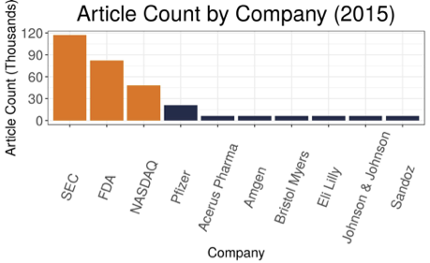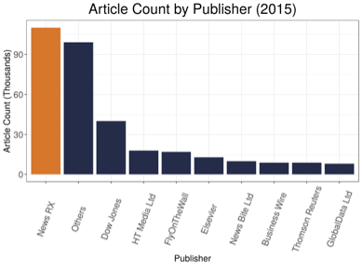
Figure 1A. Bar chart of most frequently-mentioned companies across 2015 articles. 1B. Bar chart of most frequently-sourced publishers across 2015 articles.

The figures above show the relative breakdown of company-mentions and publisher-sources for pharmaceutical articles from 2015. We observe the disproportionate representation of some entities in the data. The companies mentioned in the articles strongly favored non-pharmaceutical companies, such as the US Securities & Exchange Commission (SEC), the Food & Drug Administration (FDA), and the NASDAQ stock exchange. Similarly, NewsRX and Dow Jones are disproportionately represented as publishers in the dataset.
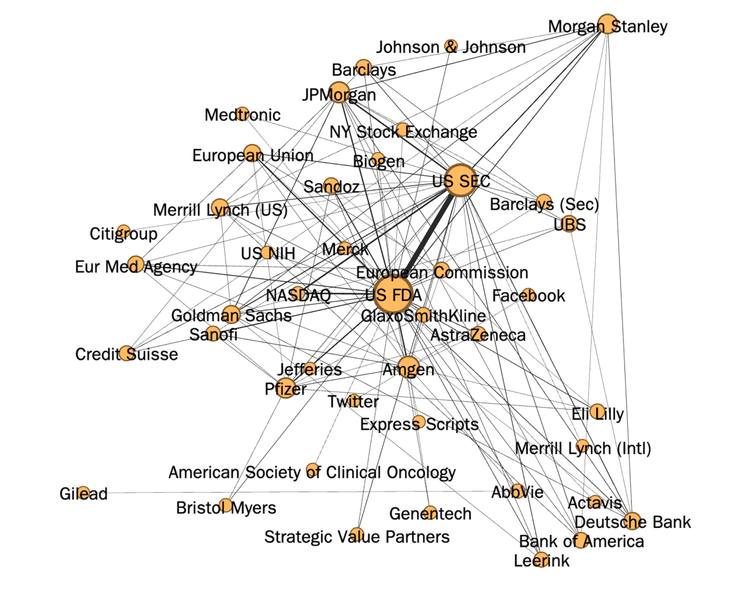
Figure 2. Company co-mentions in 2015 articles, where co-mentions between nodes exceeded 150 appearances.
The network above visualizes DNA articles’ company co-mentions in 2015, using a subset of DNA articles filtered referencing innovation keywords. The graph shows 43 nodes and 113 edges, which, for illustrative purposes, do not include edges from the subset that occur fewer than 150 times. Node sizes and edge weights represent degree centrality and number of occurrences of co-mentions, respectively.
Exploratory data analysis ultimately revealed some potential biases in the data, indicating some skew in the data towards financial or regulatory news publishers with the greatest output or easiest accessibility. The network illustrates the centrality of the FDA and SEC to the various entities as well as the significant presence of private banking companies in the articles.

Methods
After wrangling these semi-structured data into a cohesive format, the process of building predictive models for article text classification (innovation Y/N) involved 5 key steps, laid out below in Table I with relevant details.
Step | Approach | Details
Access | Utilized two methods of labeling training data:  M1 – Human labeled articles for innovation  M2 – DNA labeled articles for new product/service | n = 1000 articles random sample randomly assigned to training (80%) and testing (20%) sets
Prepare | Text processing step  - Bag of Words: Transform articles to a document-term matrix of word frequency  Dimensionality reduction step:  - Feature selection: Least Absolute Shrinkage and Selection Operator (LASSO)
Train | Supervised Machine Learning  - Penalized Logistic Regression  - Random Forest  - Gradient Boosting Machine (Trees)  - Support Vector Machines  - BERT Neural Network  Unsupervised Machine Learning  - k-Means clustering  - Hierarchical Clustering  - Bayesian Hierarchical Clustering  - Latent Dirichlet Allocation | Tuning – optimized model parameters with 5-fold Cross Validation
Optimize | Probability threshold for binary classification | Select optimal threshold via minimization of false-negative averse cost matrix
Assess | Metrics  - Receiver Operator Characteristic (ROC) Curves  - Area Under the Curve (AUC)  - Accuracy  - Precision  Bootstrap “Out-of-Bag” Validation
Table I. Outline of methods used to develop predictive models.
Results
First, all unsupervised methods elicited poor predictive models and Support Vector Machines failed to appropriately converge. Apart from Latent Dirichlet Allocation, which is a widely used method in topic-modeling in text analysis, results for these methods are omitted here.
Comparing the remaining supervised models across a variety of metrics, the BERT neural network performed exceptionally well for identifying articles which DNA labeled as concerning a new product, but such high performance was not mirrored for classifying innovation articles (Table I). The methods involving decision trees, Random Forest and Gradient Boosting Machines, consistently performed well with high ROC and accuracy (Table I, Figure ROC). Penalized Logistic Regression, considered a baseline model by performance here, was consistent but did not perform as well as the previous methods. Finally, Latent Dirichlet Allocation was found to be slightly better than flipping a weighted coin where the probability of a positive response corresponds to the proportion of positive articles in the training data, while Support Vector Machines had convergence issues and results were not obtained.
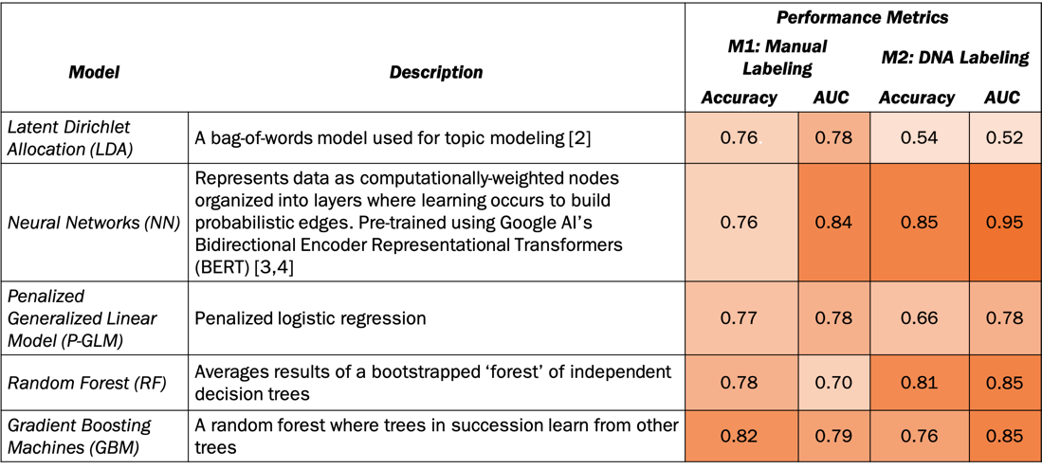
Table II. Performance metrics of supervised models against two sets of labeled DNA articles, manually-labeled and commercially-labeled. Manual labels were generated via survey to indicate whether an article described a new product; DNA labels were generated via the company’s own proprietary mechanism, a combination of sorting rules, machine-learning, and human input.

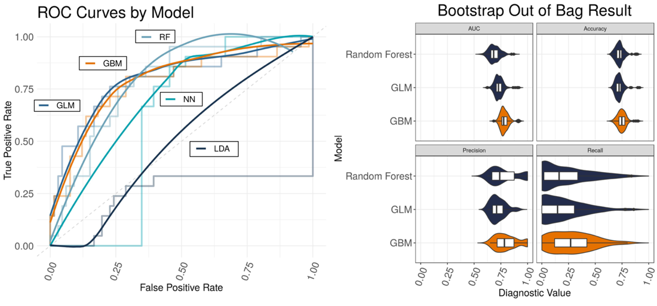

Figure 3A. ROC curves plotted with smoothed curves. LDA shows weakest performance; GBM and NN show strongest performance by accuracy and AUC. 3B. Violin plot for bootstrap out-of-bag results. GBM shows greatest performance by AUC and recall.
Following the results from the Bootstrap “Out-of-Bag" metrics, we observed that Gradient Boosting Machines were optimal models for identifying innovation across all metrics, while Random Forest and Logistic Regression were comparable but less attune to finding patterns in the text that indicated innovation. Considering each model in conjunction with corresponding diagnostics, our recommendation is the use of BERT for identifying new product or service articles (as defined by DNA) and Gradient Boosting Machines for innovation due to above 80% accuracy, robust precision – recall tradeoff, and high AUC by ROC.
Discussion
Text classification is no simple task. Different publications boast different syntax, writing style, verbiage, and structure, with trends changing over time. Wading through a mire of news articles requires methods which can reduce the dimensionality of word usage and identify key words or phrases that indicate the outcome of choice, accounting for variability in authorship between articles and publishers.
We identified two robust, highly performing methods to identify both innovation and new products or services in Gradient Boosting Machines and BERT Neural Networks, respectively. While these methods were restricted to a small sample of a much larger wealth of data, they provide a strong platform for the further exploration and identification of innovation in the pharmaceutical industry. Ultimately, the NCSES seeks to quantify and qualify innovation across all industries. The work presented here illustrates a proof of concept, that the consideration of publicly available news articles as an information source is an effective tool to supplement the BIRDIS survey.
Moving forward, as unsupervised machine learning methods (which do not rely on a priori labeled articles) were found to be insufficient predictors for innovation, this necessitates the creation of a robust survey to dissect the ontological structure present in these news articles for supervised prediction. The BERT neural network is also a relatively novel method and will be investigated further as it presents a more flexible classification methodology than any other method investigated here. The NCSES, in conjunction with the lab, will undertake the arduous task of extracting company and product names to generate and analyze the interconnected network of innovation production. In a complex world, many moving pieces contribute to and drive the quantity and quality of innovations within the country. Applications for the groundwork we have laid for predicting innovation from publicly available sources are nearly endless. With the groundwork laid and a clear goal in mind, the team will continue to fine-tune the technical machinery, extend this methodology to other industries, and develop with NCSES a suitably innovative and dynamic tool to measure and understand innovation.

References:
[1] OECD/Eurostat (2018). OSLO Manual 2018: Guidelines for Collecting Reporting and Using Data on Innovation, 4th Edition, The Measurement of Scientific Technological and Innovation Activities, OECD Publishing, Paris/Eurostat, Luxembourg.
[2] Lan, Man et al. “Text Representations for Text Categorization: A Case Study in Biomedical Domain.” 2007 International Joint Conference on Neural Networks (2007): 2557-2562.
[3] Siwei Lai, Liheng Xu, Kang Liu, and Jun Zhao. Recurrent convolutional neural networks for text classification. In Proceedings of the Twenty-Ninth AAAI Conference on Artificial Intelligence (AAAI'15). 2015. AAAI Press 2267-2273.
[4] Devlin, J; Chang, Ming-Wei; Lee, Kenton & Toutanova, Kristina. “BERT: Pre-training of Deep Bidirectional Transformers for Language Understanding.” CoRR. October 2018.

